Entry image for Geography

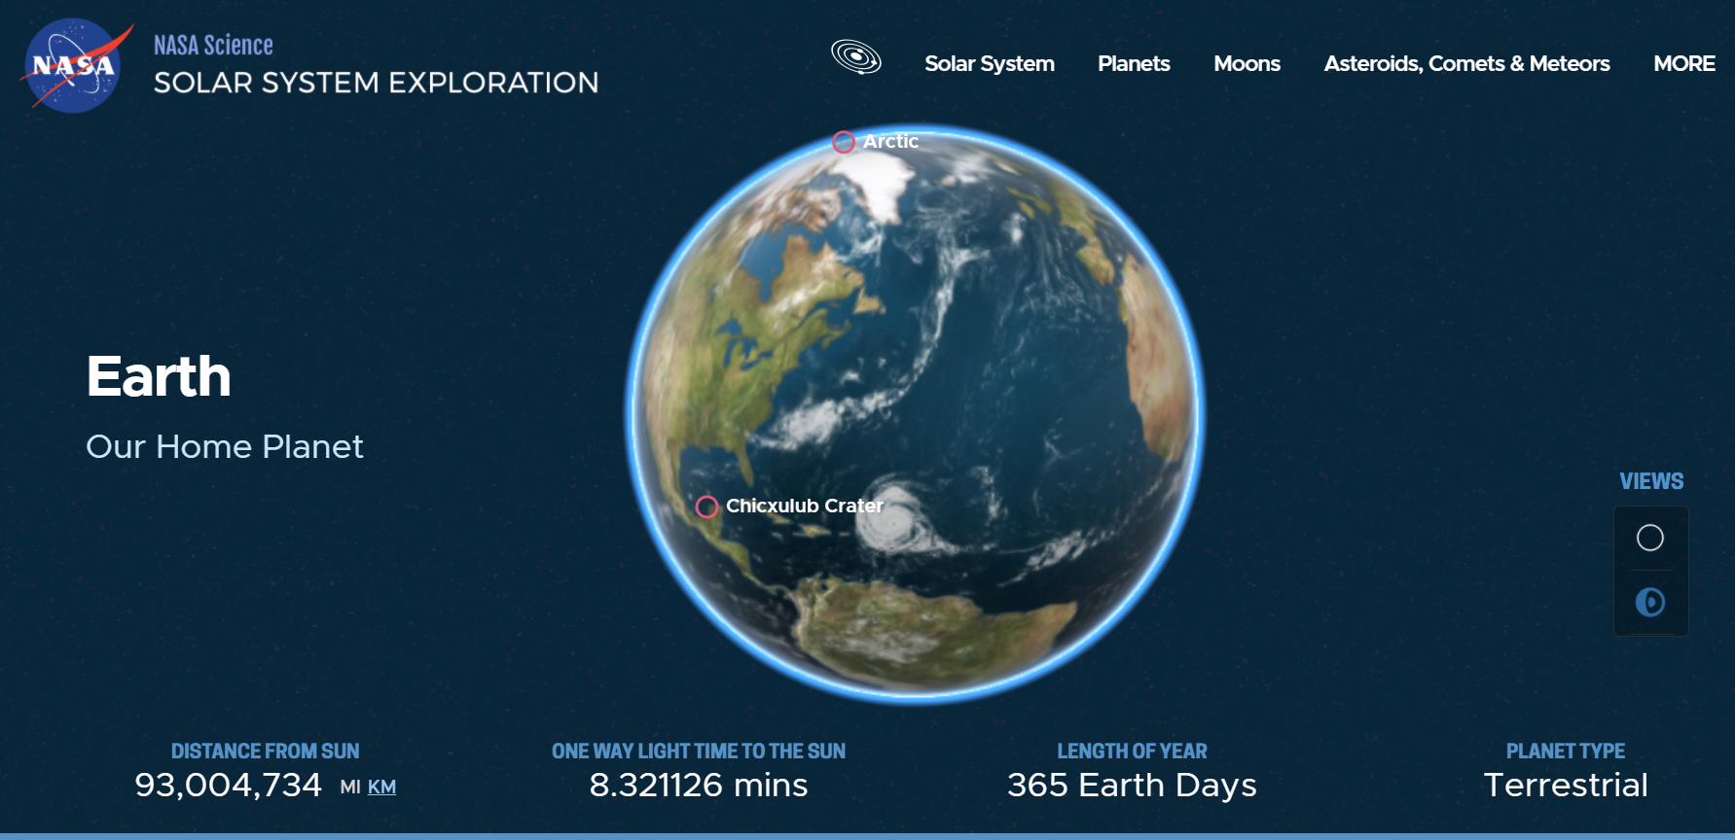

Content

Our home planet is the third planet from the Sun, and the only place we know of so far that’s inhabited by living things.

While Earth is only the fifth largest planet in the solar system, it is the only world in our solar system with liquid water on the surface. Just slightly larger than nearby Venus, Earth is the biggest of the four planets closest to the Sun, all of which are made of rock and metal.

The name Earth is at least 1,000 years old. All of the planets, except for Earth, were named after Greek and Roman gods and goddesses. However, the name Earth is a Germanic word, which simply means “the ground.”

Formation of Earth’s Geography

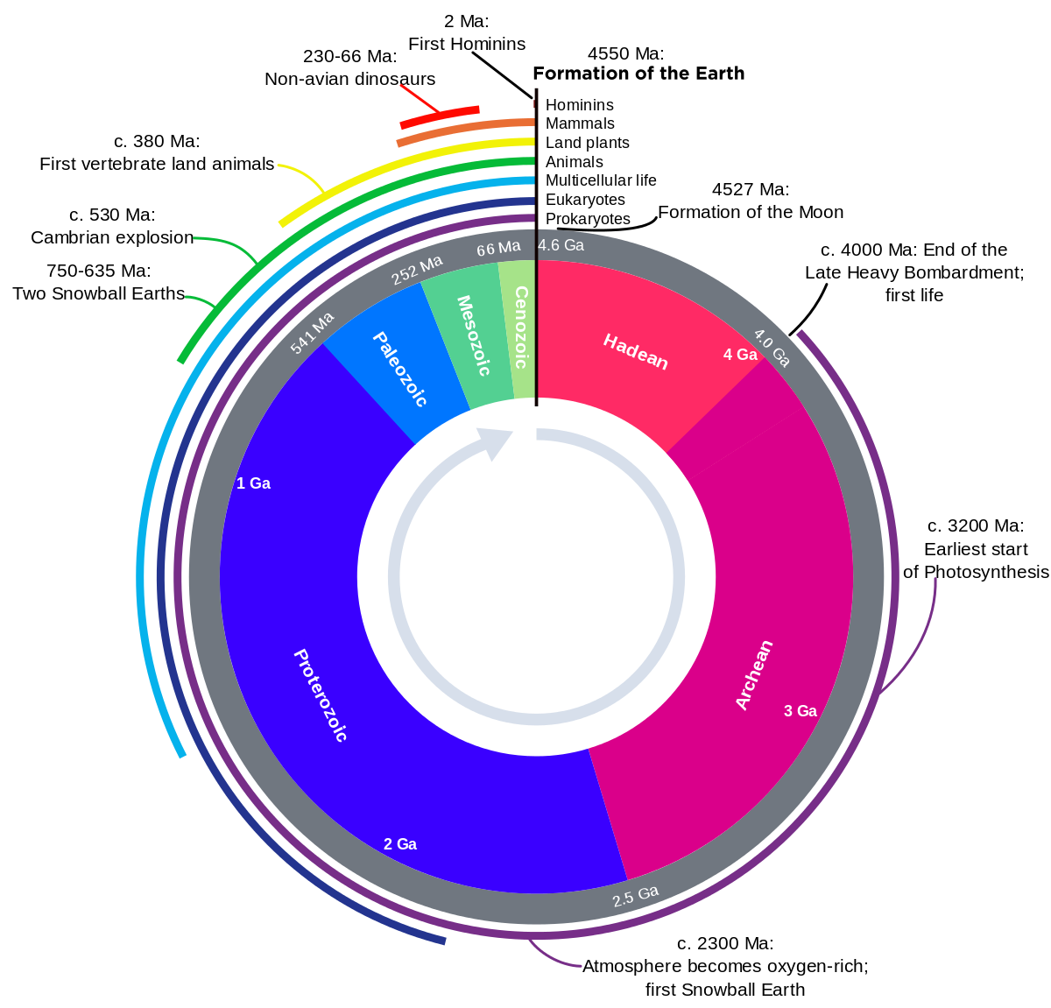

The **geological history of Earth** follows the major events in Earth's past based on the [geological time scale](https://en.wikipedia.org/wiki/Geological_time_scale), a system of [chronological measurement](https://en.wikipedia.org/wiki/Chronological_dating) based on the study of the planet's rock layers ([stratigraphy](https://en.wikipedia.org/wiki/Stratigraphy)). Earth formed [about 4.54 billion years ago](https://en.wikipedia.org/wiki/Age_of_the_Earth) by accretion from the [solar nebula](https://en.wikipedia.org/wiki/Solar_nebula), a disk-shaped mass of dust and gas left over from the formation of the Sun, which also created the rest of the [Solar System](https://en.wikipedia.org/wiki/Solar_System).

Earth was initially molten due to extreme [volcanism](https://en.wikipedia.org/wiki/Volcanism) and frequent collisions with other bodies. Eventually, the outer layer of the planet cooled to form a solid [crust](https://en.wikipedia.org/wiki/Crust_(geology)) when water began accumulating in the atmosphere. The [Moon](https://en.wikipedia.org/wiki/Moon) formed soon afterwards, possibly as a result of the impact of a planetoid with the Earth. [Outgassing](https://en.wikipedia.org/wiki/Outgassing) and volcanic activity produced the primordial atmosphere. Condensing [water vapor](https://en.wikipedia.org/wiki/Water_vapor), augmented by ice delivered from [comets](https://en.wikipedia.org/wiki/Comet), [produced the oceans](https://en.wikipedia.org/wiki/Origin_of_water_on_Earth). However, more recently, in August 2020, researchers reported that [sufficient water to fill the oceans](https://en.wikipedia.org/wiki/Origin_of_water_on_Earth) may have always been on the [Earth](https://en.wikipedia.org/wiki/Earth) since the beginning of the [planet's formation](https://en.wikipedia.org/wiki/Earth#Formation).[[1]](https://en.wikipedia.org/wiki/Geological_history_of_Earth#cite_note-SCI-20200828-1)[[2]](https://en.wikipedia.org/wiki/Geological_history_of_Earth#cite_note-SCI-20200827wu-2)[[3]](https://en.wikipedia.org/wiki/Geological_history_of_Earth#cite_note-SCI-20200827aa-3)

As the surface continually reshaped itself over hundreds of millions of years, continents formed and broke apart. They [migrated across the surface](https://en.wikipedia.org/wiki/Plate_tectonics), occasionally combining to form a [supercontinent](https://en.wikipedia.org/wiki/Supercontinent). Roughly [750](http://tools.wmflabs.org/timescale/?Ma=750) million years ago, the earliest-known supercontinent [Rodinia](https://en.wikipedia.org/wiki/Rodinia" \o "Rodinia), began to break apart. The continents later recombined to form [Pannotia](https://en.wikipedia.org/wiki/Pannotia" \o "Pannotia), [600 to 540](http://tools.wmflabs.org/timescale/?Ma=600%E2%80%93540) [million years ago](https://en.wikipedia.org/wiki/Myr), then finally [Pangaea](https://en.wikipedia.org/wiki/Pangaea), which broke apart [200](http://tools.wmflabs.org/timescale/?Ma=200) million years ago.

The present pattern of [ice ages](https://en.wikipedia.org/wiki/Ice_age) began about [40](http://tools.wmflabs.org/timescale/?Ma=40) million years ago, then intensified at the end of the [Pliocene](https://en.wikipedia.org/wiki/Pliocene). The polar regions have since undergone repeated cycles of glaciation and thaw, repeating every 40,000–100,000 years. The [last glacial period](https://en.wikipedia.org/wiki/Last_glacial_period) of the [current ice age](https://en.wikipedia.org/wiki/Quaternary_ice_age) ended about 10,000 years ago.

Exploring Earth’s interior

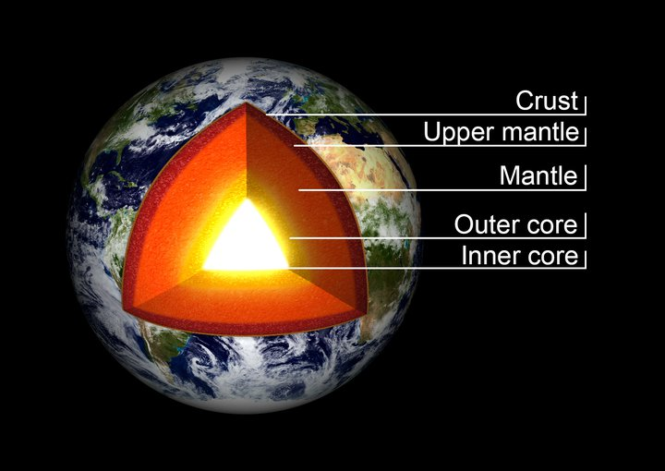

Earth is composed of four main layers, starting with an inner core at the planet's center, enveloped by the outer core, mantle and crust.

The inner core is a solid sphere made of iron and nickel metals about 759 miles (1,221 kilometers) in radius. There the temperature is as high as 9,800 degrees Fahrenheit (5,400 degrees Celsius). Surrounding the inner core is the outer core. This layer is about 1,400 miles (2,300 kilometers) thick, made of iron and nickel fluids.

In between the outer core and crust is the mantle, the thickest layer. This hot, viscous mixture of molten rock is about 1,800 miles (2,900 kilometers) thick and has the consistency of caramel. The outermost layer, Earth's crust, goes about 19 miles (30 kilometers) deep on average on land. At the bottom of the ocean, the crust is thinner and extends about 3 miles (5 kilometers) from the sea floor to the top of the mantle.

Landforms ( Yeh na kuch aesa sliding window type bna sakti hai)

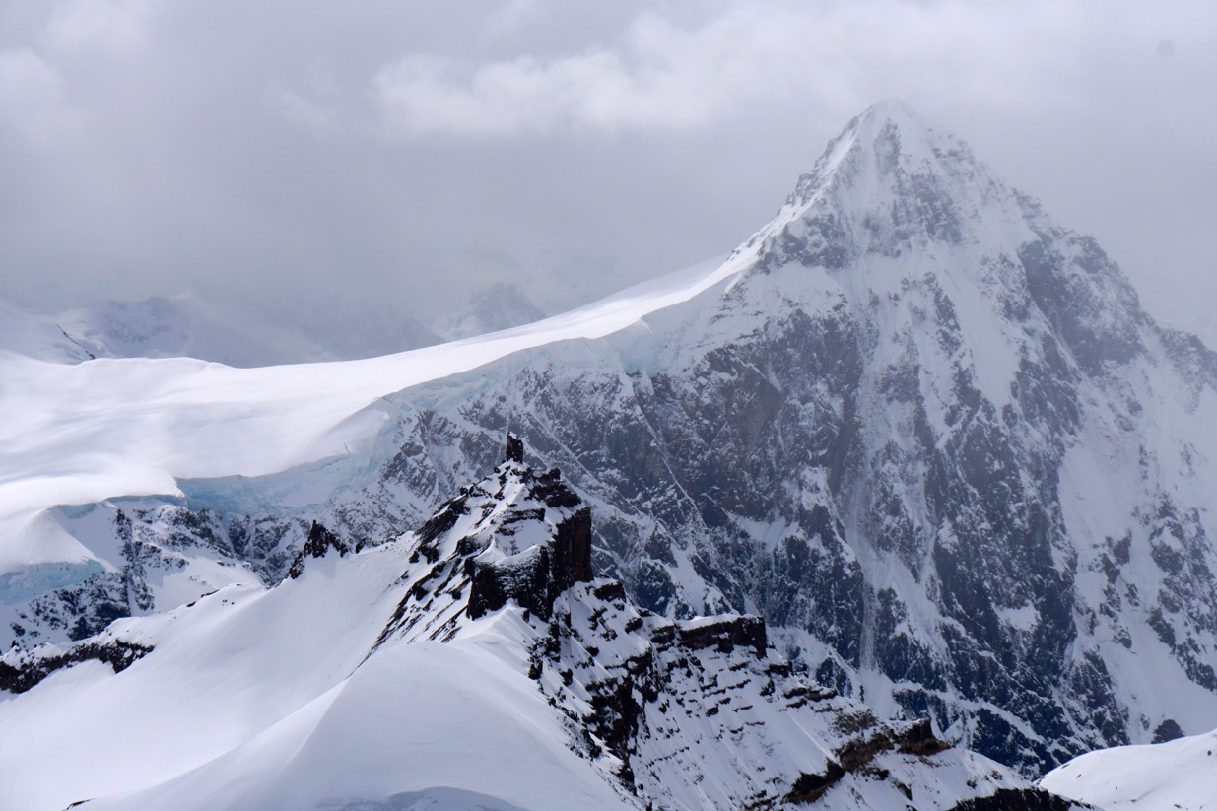

Mountains

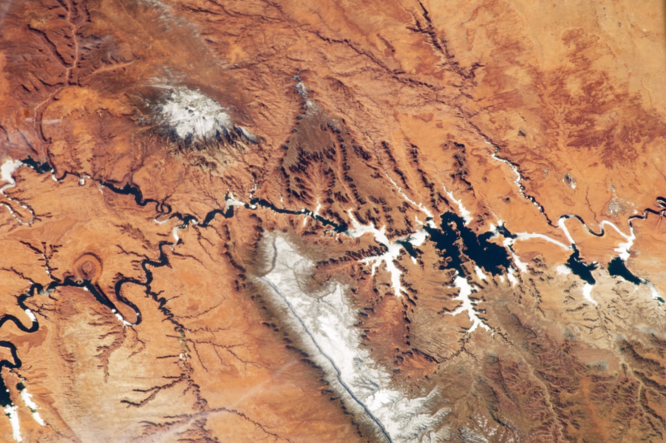Plateus

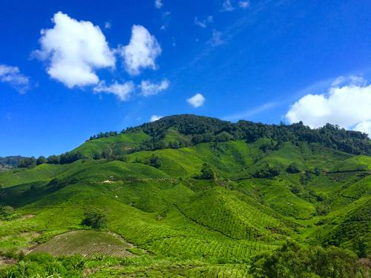

Hills

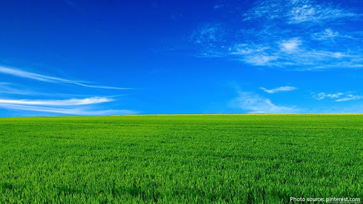

Plains